Team Nevermind

**Project 1**

**Evaluating Environmental Impact**

**Members:**

* Jana Nelson
* Yozgart Álvarez
* José Ortíz
* Rubén Colmenares
* Rodrigo Cárdenas

Environmental impact and global warming is a very important and well discussed topic nowadays, and we, as a team, are also worried about it.

**A little bit of context first…**

Before exploring the relationship of multiple variables to prove our hypothesis, we must have a clear understanding of the process of global warming.

Under normal circumstances, when sunlight hits the Earth, a proportion of its energy is stored in the ground and atmosphere, while some energy bounces off the Earth’s surface and returns into space. In the atmosphere, a collection of green house gasses is responsible for acting as a permeable barrier that reflects some energy while also allowing some to pass through, depending upon its concentration. Greater concentrations of greenhouse gasses, particularly CO2, equate to more solar radiation being reflected to the ground and hence trapped in the atmosphere, resulting in an increase in the Earth’s temperature; global warming. As the global temperature is directly related to climate conditions, global warming is an important factor contributing to the change we are seeing in our climate. While the pre-industrial concentration of greenhouse gases retained sufficient heat to sustain a relatively balanced climate that allowed life to evolve, since industrialization, the concentration has increased at an unprecedented rate and so has global warming.

There is a range of predictions from different climate models about how fast the planet is warming and how this will affect the Earth’s climate. However, what is clear is that the Earth has warmed by about 0.7°C since the Industrial Revolution. If we stopped all greenhouse gas emissions now, the Earth would still warm by another 2°C over the next couple of centuries. If emissions continue at current rates the earth will warm by 4°C before 2100.

A rise in global temperature of just 2°C may not sound drastic, particularly given that people can live sustainably over a >70°C range between the icecaps and equatorial deserts/tropics. But the impacts affect local conditions where the environment, flora and fauna, have adapted over millions of years in delicate balances. As these balances are upset, indicated by already significant changes to the Earth’s current climate conditions, they will be manifested through impacts on food production, water availability and ecosystem resilience as well as extreme weather events. These changes will be most strongly felt at local levels and affect billions of people around the world. Those most at risk are people already subjected to extreme poverty, conflict or food insecurity. Many of these vulnerable populations live in the world’s developing nations and are dependant upon fragile natural and social environments that expose them to greater livelihood risks if climate change was to threaten their sources of food, water and shelter.[1]

**Hypothesis:**

With datasets of GDP, CO2 emission, population and temperature, we want then to prove the next hypothesis:

***“Demographic growth and economic growth generate environmental impact*”**

**How we did it!?**

**Part 1. Searching for sources and datasets**

To prove our hypothesis, and as we mentioned before, first we are going to use the following datasets, with their corresponding sources:

* Gross domestic Product (GDP)
  + <http://datatopics.worldbank.org/world-development-indicators/themes/economy.html>
* CO2 emissions
  + <https://datahub.io/core/co2-fossil-by-nation#resource-co2-fossil-by-nation_zip>
* Population
  + <https://www.kaggle.com/sdorius/globses>
* Temperature
  + <https://data.world/data-society/global-climate-change-data>

To achieve that, we will merge data for every country, year over year, from 1960 to 2013 of the following datasets:

* GDP vs CO2 emissions + Temperature
* Population growth vs CO2 emissions+ Temperature

Making the following question: **which variable has the most environmental impact?**

**Part 2. Looking for answers**

For that, we will make a series of follow-up questions, like:

* Is there a correlation between polluting emissions (CO2) and economic growth in Mexico?
* Is there a correlation between polluting emissions (CO2) and population growth?
* Is there a correlation between temperature and economic growth?
* Is there a correlation between polluting emissions (CO2) and temperature?

**Part 3. Establishing criteria and cleaning up datasets**

As we depended on different datasets with different characteristics in between, we had to establish the criteria in order to work with them accordingly. For example, some datasets had different country names, had some weird symbols, had different countries quantities (some 193 and some more than 200, and so on), had different time frames (some had info from 1700’s and finished at 2015 or 2016, and some others with different periods), etc.

At the end we conclude with the following criteria in order to work smoothly with datasets:

* Time frame from more less the last 50 years, from 1960 to 2013
* Usage only of lowercase in country names
* Take out weird symbols, such as (), &, -, €, ™, etc.
* Homologation of country names, for example
  + plurinational state of bolivia → bolivia
  + brunei → brunei darussalam
  + republic of cameroon → cameroon
  + guinea bissau → guinea-bissau
  + islamic republic of iran → iran
  + libyan arab jamahiriyah → libya
  + st. kitts-nevis → saint kitts and nevis
  + st. vincent and the grenadines → saint vincent and the grenadines
  + republic of south sudan → south sudan
  + syrian arab republic → syria
  + the former yugoslav republic of macedonia → macedonia
  + timor-leste → timor leste
  + united states of america → united states
  + cÃ´te dâ€™ivoire → cote d ivoire
  + democratic peopleâ€™s republic of korea → democratic people s republic of korea
  + lao peopleâ€™s democratic republic → lao people s democratic republic
  + united of republic of tanzania → united republic of tanzania
* Homologation and merge of the number of countries. We agreed on using only the 193 ONU country members

Other challenges, such as:

* For GDP annual growth dataset was necessary to transpose the matrix, as the original dataset had years as columns, and the other datasets the other way around
* Temperature dataset had monthly info, so it was necessary to calculate averages and standard deviations in order to have annual info

**Observations**:

*CO2 emissions*

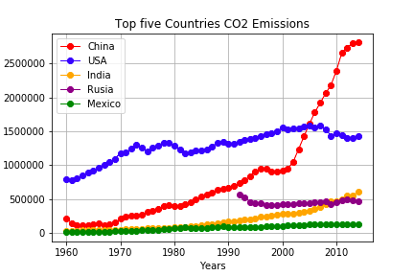

According to this, China is by much, the worldwide leader in pollution emissions, followed by United States, who contributes more less half as China. India and Russia, on their behalf, present similar CO2 levels, while Mexico has been keeping a similar pollution emissions all along the period.

China has an upward trend in all the time frame, but specially at the beginning of this century, in which it took off tremendously. On the other hand, United States presents a sustained growth in almost all the period, but with a slight fall at the end.

*Population growth*

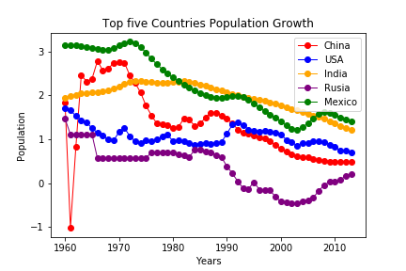

Although all countries show a general decrease in their population rate at the beginning of 1960’s, the case of India is particularly noteworthy, which never showed any increase in this indicator again. On the other hand, the other countries showed some changes in specific times.

For example, Mexico slightly increased its population rate in the 1970’s, a little less in the 1990’s and a greater upward change in the mid-2000’s. The United States presented an important increase in the 1900’s and then went down thereafter.

China is a very particular case, as it went from a positive rate in 1960’s to then fall dramatically to negative numbers in the immediate years, and then showed a fast recovery (even above when the period began). It is important to note that from the 1970’s onwards there is an interesting decrease in it’s indicator (surely justified by the "one child policy").

Finally, Russia had periods of continuous stagnation and marked periods of growth and declines, such as the late 1960’s, when the population rate fell below zero and remained relatively similar until the 1990’s. Thereafter, the rate fell further below that number and then increased slightly in the mid-2000’s.

*Temperature*

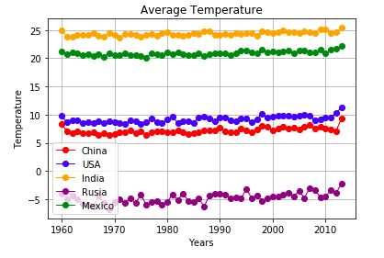

This graph clearly shows the differences in terms of temperature of warm countries compared to cold countries. Thus, for example, India and Mexico have the highest temperatures in that order during the entire period, with a sustained average of between 23 and 25 degrees for India, and between 20 and 22 degrees for Mexico. On the other hand, the United States, Russia and China show much lower average temperatures, from 10 degrees down.

We also calculate the standard deviation of temperature, in order to visualize the climate, not just the temperature. The more variable the temperature (standard deviation), the more unstable the climate would be.

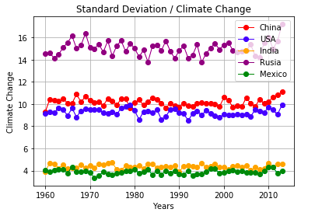

*GDP growth*

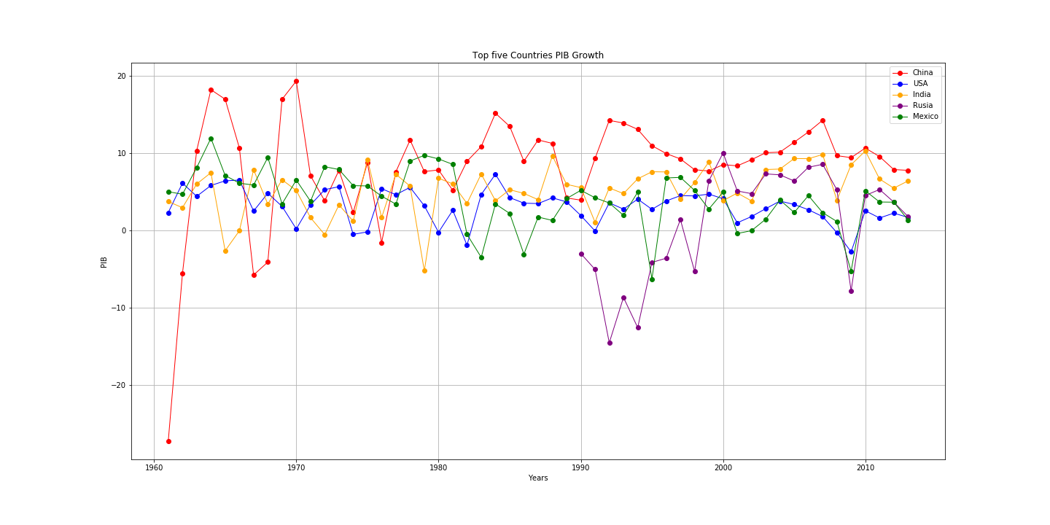

Of all the countries shown, the case of China is very interesting, because as we can see,, it went quickly from a highly negative growth rate in the early 1960’s to a growth rate of almost 20% in only 5 years, and then drop drastically in the subsequent years of that same decade, although to a lesser degree. The subsequent 20 years showed growth rates with many ups and downs, until maintaining a relatively stable indicator from the 1990’s with rates above 8% per year.

Another particular case is Mexico and the United States, where their growth rates are relatively similar (proportionally speaking). The most drastic case between these two countries is in the mid-sixties and in the late 1970’s, where Mexico exceeded by far the rate of the United States, however, the most important decline in Mexico was in 1994 for reasons that we already know.

India, on the other hand, shows a behavior relatively similar to that of China, although to a lesser extent, while the data of Russia, obtained only from 1990’s, show that they suffered from a strong economic crisis during almost all that decade, and then increased in an important way at the beginning of this century.

Finally, it is important to point out that Russia, Mexico and the United States (in that order) were the countries that suffered the most during the economic crisis of 2009, having significant decreases. Only China, and to a lesser extent India, had growth, but lower than those shown in previous years.

Currently, all countries show growth between 2 and 8 percent, with Mexico and China the countries with the most differences among them.

**Climate change: A quick glance of Mexico**

*CO2 Emissions (tons) vs Average temperature (Cº)*

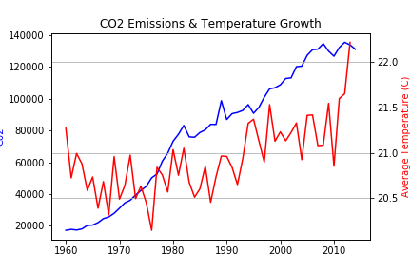

As we can see above, the annual CO2 emissions shows a practically uninterrupted growth along time. There are some little drops, specially at the middle of the 80’s and 90’s decades, but all of them with an upward trend at the end.

Regarding the annual average temperature, and unlike the CO2 emissions graphic, there are very pronounced increases and falls during all the time frame, but also with an upward trend. Important to say that, unfortunately, in the last 10 years, the average temperature have shown no sign of going down, but on the contrary, it has raised almost 2º C and seems to keep going up.

We can say then, that there is a relatively correlation between this two variables, meaning that from our point of view, in Mexico the CO2 emissions can be part of the equation in the constantly growing up temperature.

*CO2 Emissions vs Population*

As shown in the following graphic, while the CO2 emissions keeps going up, the population rate goes down dramatically.

For example, in the 60’s this rate was above 3 percent, while the emissions were in the lowest level during this time period. On the contrary, at the end of the period the variables show totally the opposite (the population growth is almost on the lower level and the emissions on the top).

At the end, we can say that definitely there is no correlation between this two variables, meaning that the constantly population growth in Mexico is no direct causation of the fast pace growth of CO2 emissions.

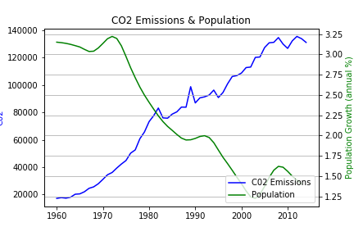

*CO2 Emissions vs GDP growth*

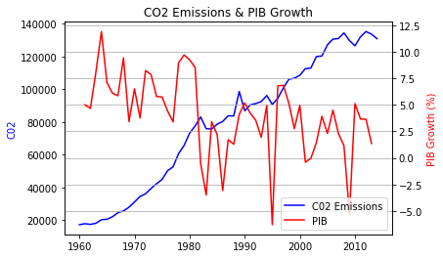

As we have seen before, the CO2 emissions constantly have grown during the last 50 years in Mexico, but the mexican GDP growth has a very particular behaviour, because it has very pronounced peaks and valleys along the same period, but at the end we can see that there is a little trend behind this: it goes slightly down.

At the beginning of the 80’s, we can see that there was a huge fall in the GDP growth, but the emissions kept going up, meaning that despite this fall in the production of goods and services there was no change in the pace of CO2 emissions. This behaviour can be seen as well when Mexico suffered its economic crisis in 1994-1995 and then in 2008-2009.

Our conclusion with this pair of variables, at least for Mexico, is that there is no correlation within.

*GDP vs Temperature*

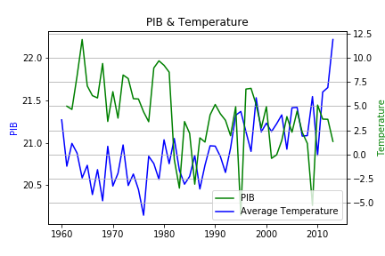

Unlike CO2 emissions vs GDP growth and CO2 emissions vs population, here we can see that there is a relatively close correlation between economic growth and temperature, as seen also with CO2 emissions vs average temperature.

In general terms we can assume this affirmation along almost the entire period, but it’s important to mention that this conclusion does not apply to four particular time frames: the beginning of the 60’s, in the middle of the 90’s, the end of the last decade and from 2012-2013 and so on.

**Driving into conclusions**

So...

**Is there a correlation between polluting emissions (CO2) and economic growth in Mexico?**

Our conclusion with this pair of variables is that there is no correlation within.

**Is there a correlation between polluting emissions (CO2) and population growth?**

Definitely there is no correlation between this two variables.

**Is there a correlation between temperature and economic growth?**

There is a relatively close correlation between

**Is there a correlation between polluting emissions (CO2) and temperature?**

Yes, the emission of CO2 and the temperature correlates. Correlation is not causality, but they are variables recognized by scientists as causal.

1. MercyCorps. Climate change in context.